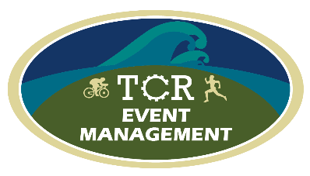
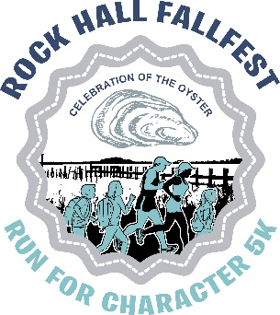
Run For Character 5k Run/Walk
Join the Family Fun at the Rock Hall FallFest
When: Saturday, Oct 8th, 2022, 9am start. RAIN or SHINE. FREE Kiddie K Run (10 and Under) starts at 8:50am

Where: Waterman’s Crab House & Dock Bar, 21055 East Sharp Street, Rock Hall, MD 21661

Registration: $25 until Sept 30; $30 after and on event day. Registration starts at 8am. Online registration prior to race day. Please go online to register at www.RunSignUp.com/RunForCharacter. Cash and Checks accepted on Race Day ONLY. Questions? Email us at info@TCREventManagement.com

Donation: Can’t make it to the event but still want to support our cause? Consider our DONATE button at
www.RunSignUp.com/RunForCharacter

Awards: Awards to overall male/female and masters winners, top 3 male/female runners in 5 year age
Groups and top 5 male/female walker finishers. Ribbons to all Kiddie K finishers. The awards
Ceremony will be held immediately following the final finisher.

SWAG: Quality “Run For Character” tech shirts for all of our registered participants.

FallFest: FallFest is an annual celebration of family, community, and oysters. Live music, entertainment, vendors, artisans, and food will be offered. Rock Hall is a charming waterfront town on the Chesapeake Bay. More information can be found at www.rockhallfallfest.org or www.RockHallMD.com
Our Mission: We want to create community spirit by working together to promote growth and to seek ways to
Make Rock Hall a better place to live and work. A portion of the proceeds will benefit Character Counts of Kent County, a non-profit organization that encourages strong ethical values through the Six Pillars of character and the Rock Hall Elementary School, supporting student education programs.

WAIVER AND RELEASE OF LIABILITY: I know that running/walking or rolling (wheelchair) in a road race is a potentially hazardous activity. I should not enter and run/walk unless I am medically able and properly trained. I assume all risks associated with running/walking this event including, but not limited to, falls, contact with other participants, the effects of the weather, including high heat and/or humidity, extreme cold, the conditions of the road and traffic on the course, all such risks being known and appreciated by me. Having read this waiver and knowing these facts, and in consideration of your accepting my entry to participate in the Rock Hall Fall Fest Run for Character 5K Run/Walk, I, for myself and anyone entitled to act on my behalf, waive and release TCR Event Management, Main Street Rock Hall, Waterman’s Crab House & Dock Bar, The Town of Rock Hall, The State of Maryland and all sponsors, their representatives and successors from all claims or liabilities of any kind arising out of my participation in this event even though that liability may arise out of negligence or carelessness on the part of the persons named in this waiver. I hereby give my permission to the event organizers and sponsors to use my name and/or picture in any publication, broadcast, telecast or other account of this event without limitation or obligation of further compensation thereof. Unofficial entrants will be disqualified as determined by TCR Event Management. Fees are non-refundable or transferable. I certify that I have read this wavier and release and fully understand its significance.

REGISTER Online here:
WWW.RunSignUp.com/RunForCharacter

